**SPH3U 12.4 Solenoids**

1. **Interacting magnetic fields**

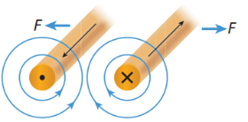

|  |  |  |
| --- | --- | --- |
| Magnetic fields interacting: |  | |
| example |  |

1. **Solenoids**

|  |  |
| --- | --- |
| Coiled conductors: |  |
| Electromagnet: |  |
| Solenoid: |  |

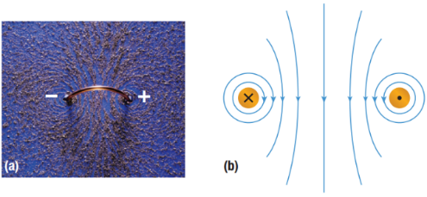 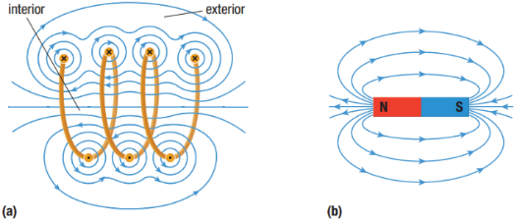

|  |  |
| --- | --- |
| Right-hand rule #2: |  |

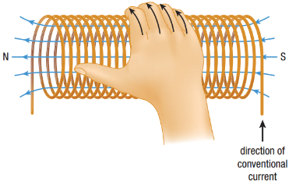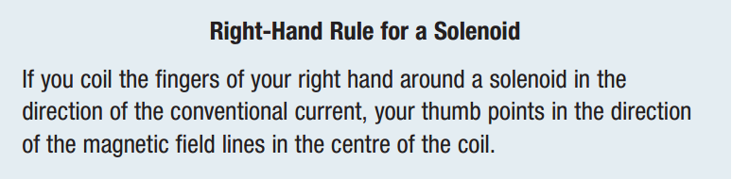

Draw the magnetic field lines and/or the direction of conventional current for each:

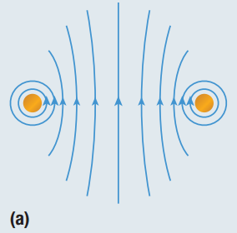 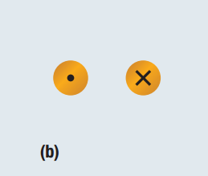 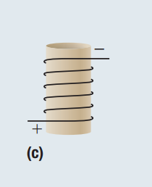 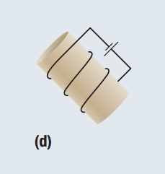

**Homework:** page 562: #1-4